**Density Creates Currents**

**Why is density important? Changes in density drive many of Earth’s processes!**

# Convection Cells

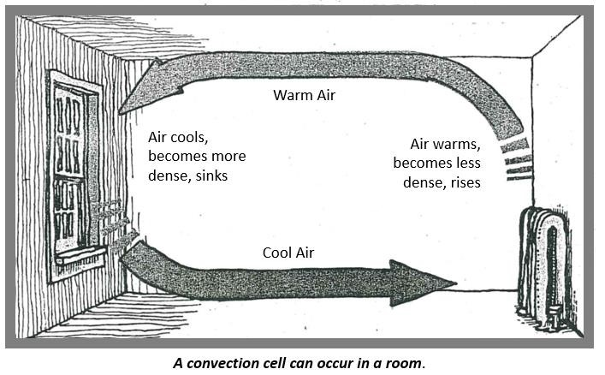

**Figure 1**

To understand how convection works, imagine a room in a house, like the one shown in the picture above. One side of the room has a heater; on the opposite wall is a window. On a cold winter day, when the heat is on, air near the heater will warm up. What happens to hot air? It expands, becomes less dense, and rises. Upon reaching the ceiling, it is pushed along by more hot air rising behind it. The heated air cools down as it moves away from the heater, and this process is speeded up when it meets the cold window. As the air cools, it becomes more dense, sinks to the floor, and eventually completes a circuit in the room. A circular convection current is set up. Circular currents like this are called convection cells. Convection currents like this also take place in the atmosphere (see the picture below), causing global and local wind patterns.

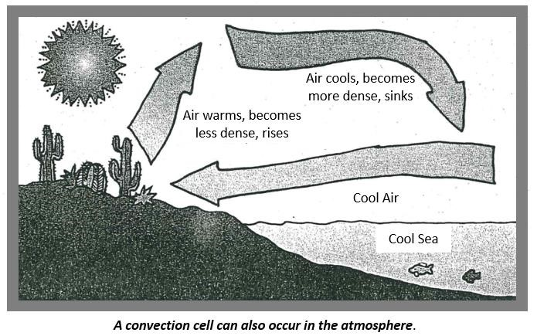

**Figure**

**2**

# Ocean Currents

Convection works in liquids as well as in gases. Ocean currents have several different causes, many of which are due to changes in density. Some ocean currents are convection currents.

Under the tropical sun, water at the equator warms up. At the cold poles, seawater cools down and sinks. Convection cells are set up with warm water moving along the surface to the poles and deep cold water flowing toward the equator. Changes in density, caused by changes in salinity (the amount of salt in the water), are also important in the formation of ocean currents. Ice formation near the poles leaves salt behind in the remaining water. This denser, more saline water sinks, creating its own density-driven currents. Surface winds also set surface currents into motion.

# Figure 3

## Moving and Making Mountains

Convection currents can move or split whole continents. Radioactive substances deep within the Earth provide the heat that drives these currents (see Figure 4 illustrating how these convection cells work).

Earth’s surface is made up of a series of giant plates that fit together like a moving spherical jigsaw. These plates can be made from two types of crustal material: dense oceanic crust and comparatively less dense continental crust. The hot rocks deep in the mantle behave like a soft plastic. These warm, less dense rocks move up, pushing aside rock that lies on the surface. These convection currents create some of the mountain ridges found on the ocean bed. The Mid-Atlantic Ridge is one example. Sometimes these ridges emerge at the surface of the ocean as islands. As plates expand, they push against other plates. When plates that consist of two pieces of continent push against one another, they may buckle up along their boundaries to form great fold mountains. They may also slide past one another, as at the famous San Andreas Fault in California. Earthquakes can occur as the plates slide past one another or build mountains. If a plate of more dense oceanic crust pushes against less dense continental crust, what do you think happens? The more dense ocean crust sinks down to create ocean trenches. Evidence for this process is provided in the form of the volcanoes and earthquakes that are caused by all this activity.

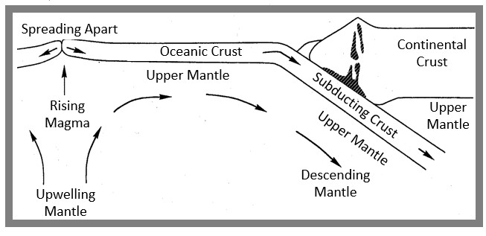

**Figure**

**4**

## DENSITY CREATES CURRENTS Questions Name____________________________

1. Which is **denser**, warm or cool air?

1. Air that is more dense will rise / fall (circle one) and air that is less dense will rise / fall.

1. a. In a home, what would cause air to warm up and rise?

* 1. In a home, what would cause air to cool and sink?

* 1. What would make that cooler air actually rise again?

1. In the atmosphere (see Figure 2), what is the source of heat that causes air to warm?

1. During the daytime, when the sun is shining, what direction is the air current, in the form of wind, traveling? Explain.

1. How do you think the winds shown in Figure 2 would be different at night, when the sea water temperature would be warmer than the air temperature? Explain.

1. Name **two** factors that affect the density of ocean water.

1. How are ocean currents formed? Be detailed in your answer.

1. Explain how the density of oceanic crust and the density of continental crust are major factors in the formation of mountain ridges and ocean trenches.

1. a. Convection currents can occur in _________________________ , such as ocean currents; and also in ______________________, such the currents that cause wind.

* 1. However, crustal plates are solid. Below, explain how currents based on density affect them, anyway.